

TITLE OF WORK IN ENGLISH LANGUAGE (STYLE 'TITLE-eng')
First author's name and surname, Name of institution,
Name and surname of the second author, Name of institution
Name and surname of the third author, Name of institution'Authors' style

Abstract: The volume of the abstract in English cannot be more than 250 words. A maximum of 5 keywords follow below the abstract.
Keywords: traffic, transport, road safety, logistics (For both abstract and keyword use style 'Summary - Keywords').

INTRODUCTION (Style '1. Heading')
Use this template to prepare your work. All settings in the text are made using styles that are defined and are located in the header of the Word word processing program (in the Home tab). It is not allowed to change the margins and dimensions of the paper.
The name of the document should be written in the Latin English alphabet (without the letters š, č, ć, đ, ž), so that the surname and first name of the first author and the title of the paper or part of the title of the paper are visible (MARKOVIC M. et al. Self-reported behavior of sand on the streets of the municipality...doc).
The text is formatted by placing the cursor in a certain paragraph or by marking the text that needs to be formatted with the appropriate style, and then selecting the appropriate style in the upper right corner (Home/Styles). All text must be typed in 'Text' style.
Prepare the text in single-column format using the MS Word program (we recommend version 2007 or later). The scope of work is maximum8 pages of A4 format (that is, a maximum of 30,000 characters, formatted according to these instructions).Text margins are set automatically and do not need to be changed (left: 2.5 cm; bottom: 2 cm; right: 2 cm; top: 2 cm).
Use the decimal classification of the content of the work, so that the numbering of titles and subtitles is done automatically by selecting the appropriate style ('1. Title', '2. Title', '3. Title').
All necessary settings for text formatting are stored in differently named styles. By selecting specific text (or positioning the cursor within a paragraph to edit) and the appropriate style, a variety of pre-defined settings can simply be applied.
The simplest way to prepare a paper is to directly type the text of the paper in this paper writing guide.
Use hyphens when specifying the value.
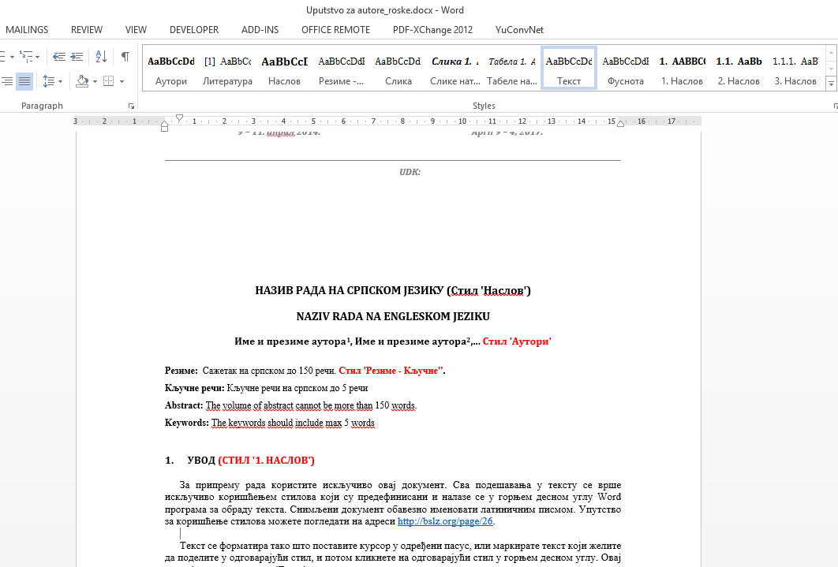
- Position for setting styles in the program (Word 2007 and later versions) 'Figure caption' style

STRUCTURE OF THE WORK (Style '2. Title')
It is common for research papers to include:
- Introduction(description of the problem, space and time of research),
- Material and methods(How we analyzed and solved the problem),
- Results(What we found/determined),
- Discussion(What does that mean),
- Conclusion(A brief overview of the findings related to the problem defined in the Introduction),
- Thank you note(Declaration of gratitude for help) i
- Literature(According to this instruction, list the sources that were used in the paper. It is necessary to list at least five sources).

PICTURES AND TABLES
Place pictures (and diagrams, etc.) and tables within the text in a suitable place (it is not necessary to place pictures and tables in the place where they are discussed, but they must be listed after the paragraph in which the reader is referred to the picture or table).
For formatting images (and diagrams, etc.) use 'Pictures' style. Use to format captions under pictures (and diagrams, etc.) 'Image caption' style, and for the text above the table (name – explanation of the table) 'Table caption' style.
Photos (color or black and white) should be of good quality and suitable for printing. If more than one type of data is displayed on the image, it is necessary that the image has a suitable legend.
- Number of traffic accidents, Serbia, 2011. 'Table caption' style
Year | Traffic accidents with fatalities | Traffic accidents with material damage
2011. | 3 | 5

NUMERICAL VALUES
Numerical values ​​used in the text, images and tables should be written as follows:
- 1/2 → 0.5 or 1/2 (not 0.5);
- one thousand one hundred thirty three → 1.133 (not 1 133 nor 1.133);
Use SI units.

MATHEMATICAL FORMULAS
Use the Word Equation Editor to write mathematical formulas.
Matrices should be written in square brackets.
Mathematical formulas should be indented 5 mm from the left margin:

(1)

Formulas should be numbered with Arabic numerals in parentheses and use right alignment. Formulas and formula numbers should be written in the given table without visible lines (as in the example).
Separate the formulas from the text with a single blank line.

CALL FOR LITERATURE IN THE TEXT
Use footnotes only for accompanying comments and explanations. Quotations in the text should not be marked with footnotes, but at the end of the quotation or when referring to someone's work. Reference to the appropriate source is made using a round bracket in which the authors and the year of publication are mentioned. When citing, the following are written in parentheses: surnames of authors, year of publication (Lipovac and Nešić, 2005).
If there are more than two authors of the cited work, then only the last name of the first author is written and the abbreviation is added: et al. (Lipovac et al., 2009).
A comma separates the author from the year of publication, and a semicolon (;) separates different authors of different works. The page number is separated from the year of publication with a colon (:) (Milićević, 2018:20).
If the same author is cited with several works from the same year, then alphabetical letters are added to the works next to the year (for example: Jovanović, 1998a; 1998b), taking care to mark them in the same way in the literature (the year of publication should be accompanied by a letter designation, 1998a).
When quoting sources from the Internet, it is stated: Surname, I. / Name of the organization. (if the author is not listed, specify the name of the site). Year of publication. Page title. Date when the text was downloaded from the website, website name or URL (Kraizer, S. (2005). Safe child. Retrieved 02/29/2008, from http://www.safechild.org/.). Reference to the regulation is made by stating the name of the regulation, article and, if necessary, paragraph and point in parentheses or in a footnote (Law on Road Traffic Safety, Article 10, Paragraph 2, Item 14).
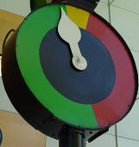
VMS systems.'Figure caption' stylе

LITERATURE (Style '1. Title')
Use APA citation style for citing references (https://owl.purdue.edu/owl/research_and_citation/apa_style/apa_formatting_and_style_guide/general_format.html). Order the references according to the first author's last name, alphabetically or alphabetically and the year of publication. Regulations and documents without authors should be placed after the titles for which the authors are given. References should be presented in the original letter, according to the form shown in the example. To write references use 'Literature' style, where the numbering is done automatically.

- Elvik, R., Vaa, T. (2004). The Handbook of Road Safety Measures. Elsevier.
- Hauer, E. (1986). On the estimation of the expected number of accidents, Accident Analysis and Prevention, 18 (1), 1-12.
- Lipovac, K., Nešić, M. (2005). European action program for traffic safety - halving traffic accident victims in the European Union by 2010 - shared responsibility. Bezbednost, Belgrade, 47(3), 513-533.
- Lipovac, K., Jovanov, D., Jovanović, D. (2009). A modern approach to improving road safety. Road and Traffic, 56(4), 32-37.
- Law on road traffic safety (2009), Official Gazette of the Republic of Serbia, No. 41/2009, 53/2010, 101/2011, 32/2013 - US decision, 55/2014, 96/2015 - others. law, 9/2016 - US decision, 24/2018, 41/2018, 41/2018 - dr. law, 87/2018, 23/2019, 128/2020 - dr. law, 76/2023 and 19/2025.
- Rulebook on traffic signaling (2017), Official Gazette of the Republic of Serbia, No. 85/2017, 14/2021 and 21/2024.
- Vias institute. (2023). Serbia – ESRA3 Country Fact Sheet. ESRA3 survey (E-Survey of Road users’ Attitudes). Version 2 (01/2024). https://www.esranet.eu/storage/minisites/ esra2023countryfactsheetserbia.pdf.
- Pluto Logistics (2024, August 20). The remote control of tachographs in the EU officially starts - Are all countries ready?.https://plutonlogistics.com/road-transport/the-official-start-of-the-tachograph-control-starts-in-the-eu-are-all-countries-ready/.

Title (e.g. Ph.D., M.Sc.), first and last name of the author, title (e.g. B.Sc. traffic engineer), title (e.g. professor, head), institution (name, street and number, city, country), e-mail -'Footnote' style
Title (e.g. Ph.D., M.Sc.), first and last name of the author, title (e.g. B.Sc. traffic engineer), title (e.g. professor, head), institution (name, street and number, city, country), e-mail -'Footnote' style
Title (e.g. Ph.D., M.Sc.), first and last name of the author, title (e.g. B.Sc. traffic engineer), title (e.g. professor, head), institution (name, street and number, city, country), e-mail -'Footnote' style

